**Exercise 3: Assertions in Junit**

**Scenario:**

You need to use different assertions in JUnit to validate your test results.

**Steps:**

1. Write tests using various JUnit assertions.

**STEP 1 – WRITING TESTS USING VARIOUS JUNIT ASSERTIONS.**

* Created a class named “Testing3.java” under the Junit Testing Project.

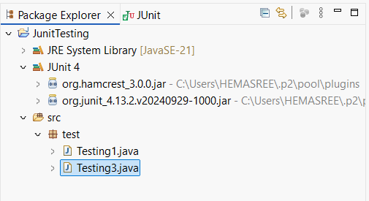

* Writing tests using various Junit assertions.

**Code:**

|  |
| --- |
| **package** test;  **import** org.junit.Test;  **import** **static** org.junit.Assert.*;  **import** java.util.Arrays;  **import** java.util.List;  **public** **class** Testing3 {  @Test  **public** **void** testBasicAssertions() {    *assertEquals*("Sum should be 5", 5, 2 + 3);  *assertTrue*("5 is greater than 3", 5 > 3);  *assertFalse*("3 is not greater than 5", 3 > 5);  Object obj = **null**;  *assertNull*("Object should be null", obj);  Object nonNullObj = **new** Object();  *assertNotNull*("Object should not be null", nonNullObj);  }  @Test  **public** **void** testArrayEquals() {  **int**[] expected = {1, 2, 3};  **int**[] actual = {1, 2, 3};  *assertArrayEquals*("Arrays should be equal", expected, actual);  }  @Test  **public** **void** testSameAndNotSame() {    String s = "hello";  String t = s;  *assertSame*("Should be same reference", s, t);  String a = **new** String("hello");  String b = **new** String("hello");  *assertNotSame*("Should not be same reference", a, b);  }  @Test  **public** **void** testListContents() {  List<String> expected = Arrays.*asList*("A", "B", "C");  List<String> actual = Arrays.*asList*("A", "B", "C");  *assertEquals*("Lists should be equal", expected, actual);  }  @Test  **public** **void** testWithFailureMessage() {    **int** value = 5;  *assertTrue*("Value should be less than 10", value < 10);  // assertTrue("Value should be less than 3", value < 3);  }  } |

**Output:**

